LAB 5
WebApi_Handson
1. JWT Token Generated
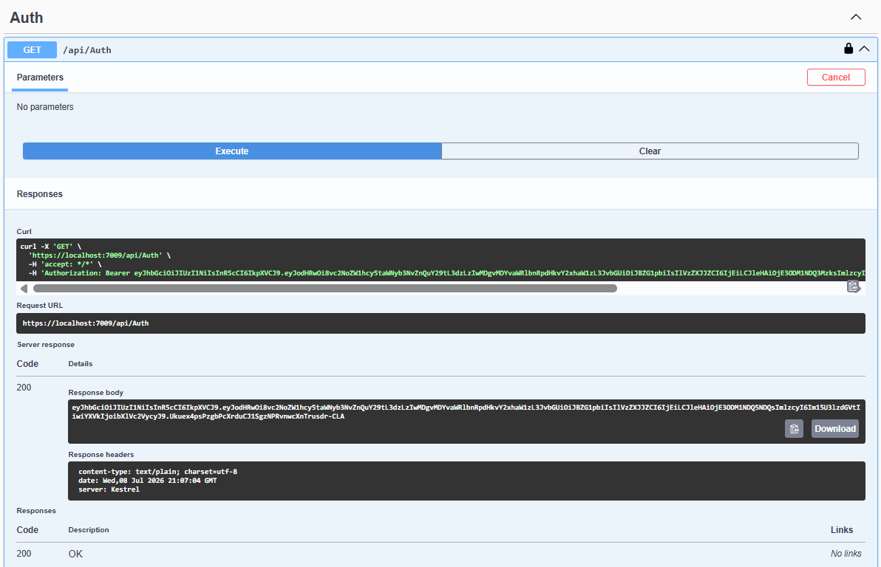

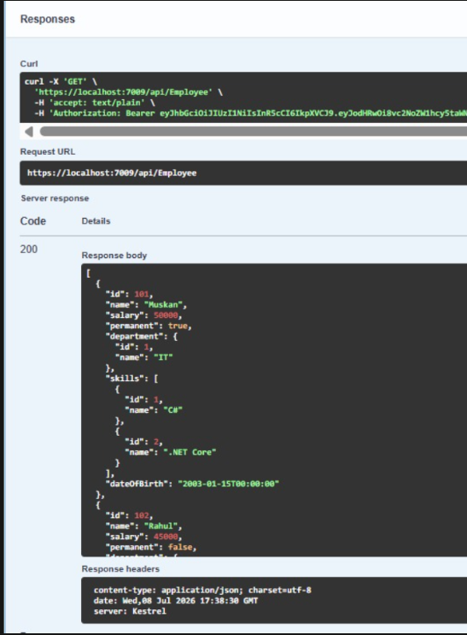
2. Valid Token

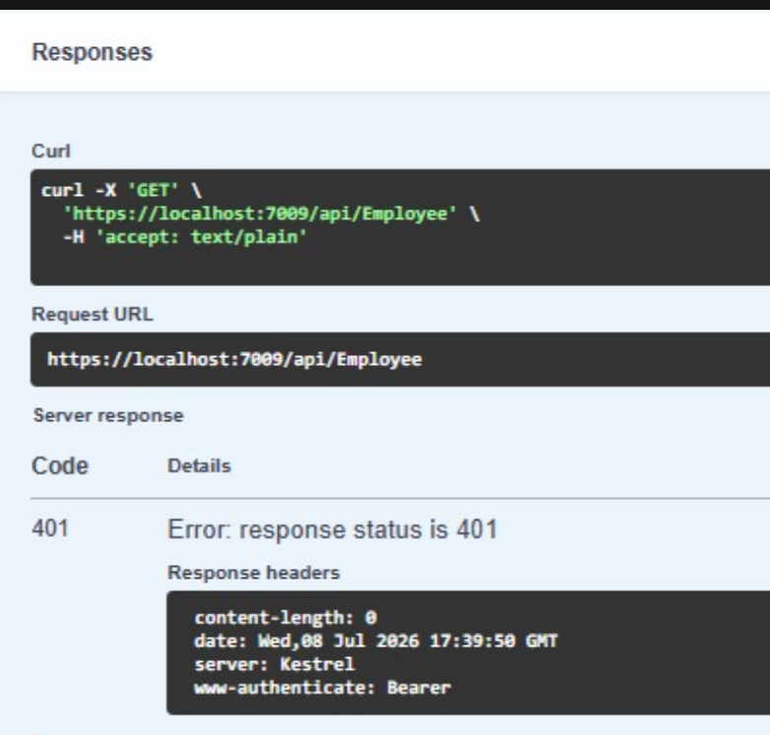
3. Expired Token

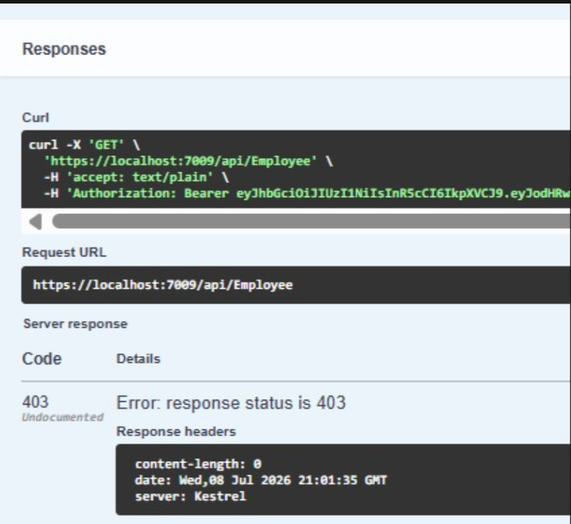
4.Role Test (POC Only)

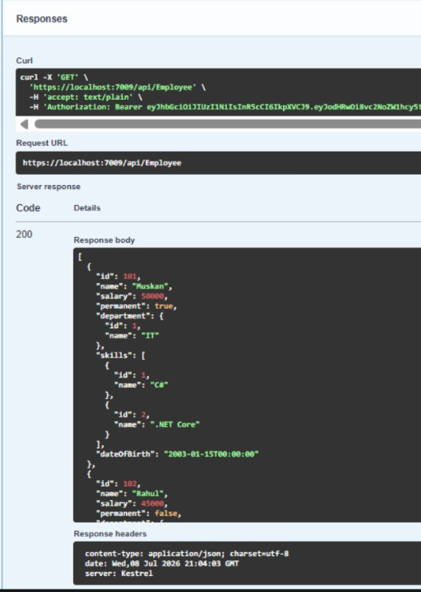
5.Role Test (Admin,POC)

6. Build Success
